**Enayathulla A**

**Python Test (20/12/2023)**

**I give all needed description in code file as command lines.**

**Question 1: Explain Python Module with examples, Import module in Python.Renaming the Python module.**

**Input:**

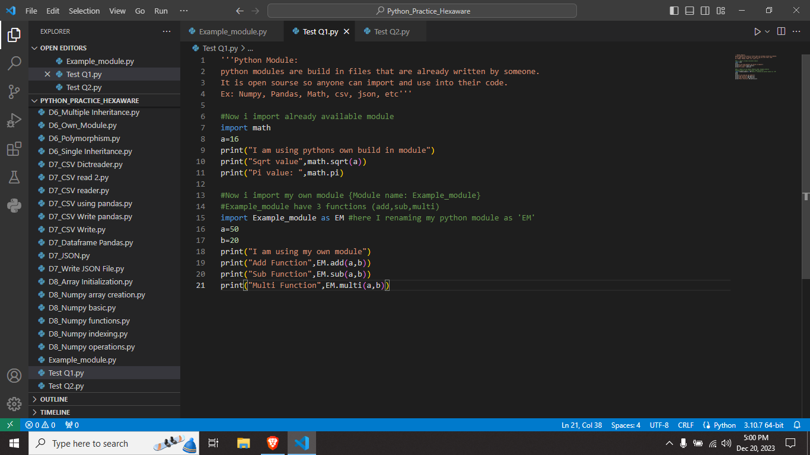

**My own module:**

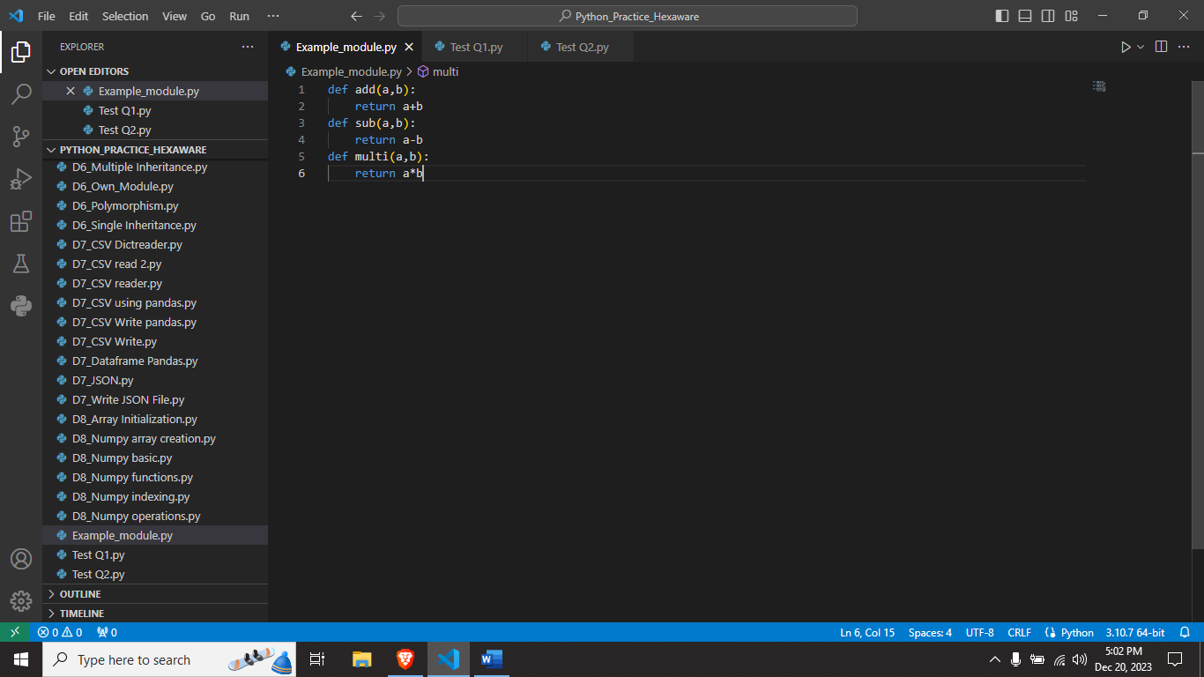

**Output:**

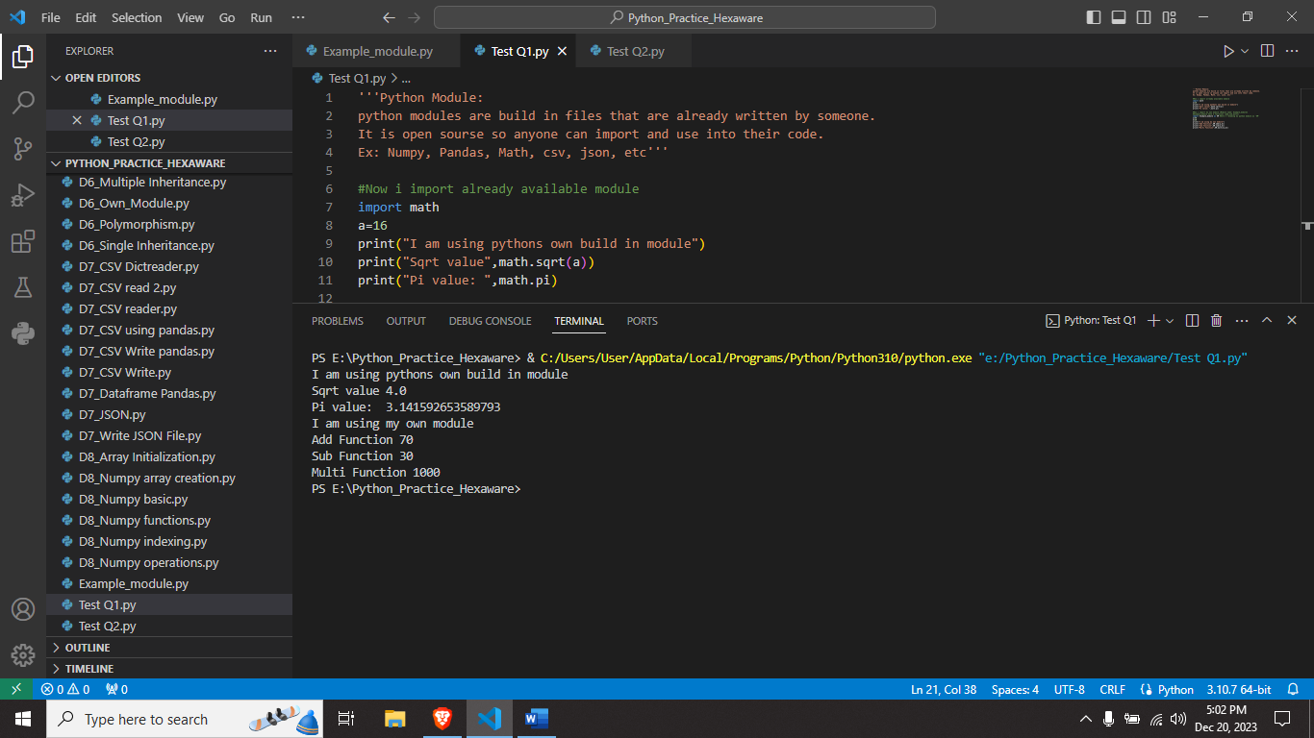

**Question 2: Explain Pandas and numpy using Examples in PYTHON**

**Input:**

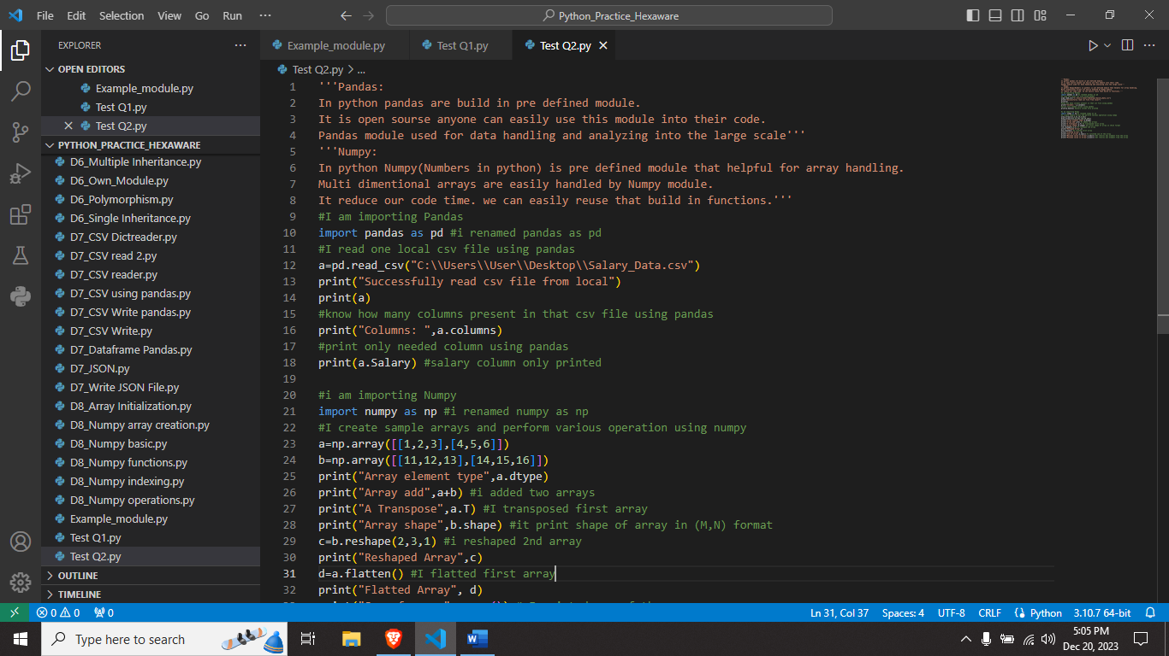

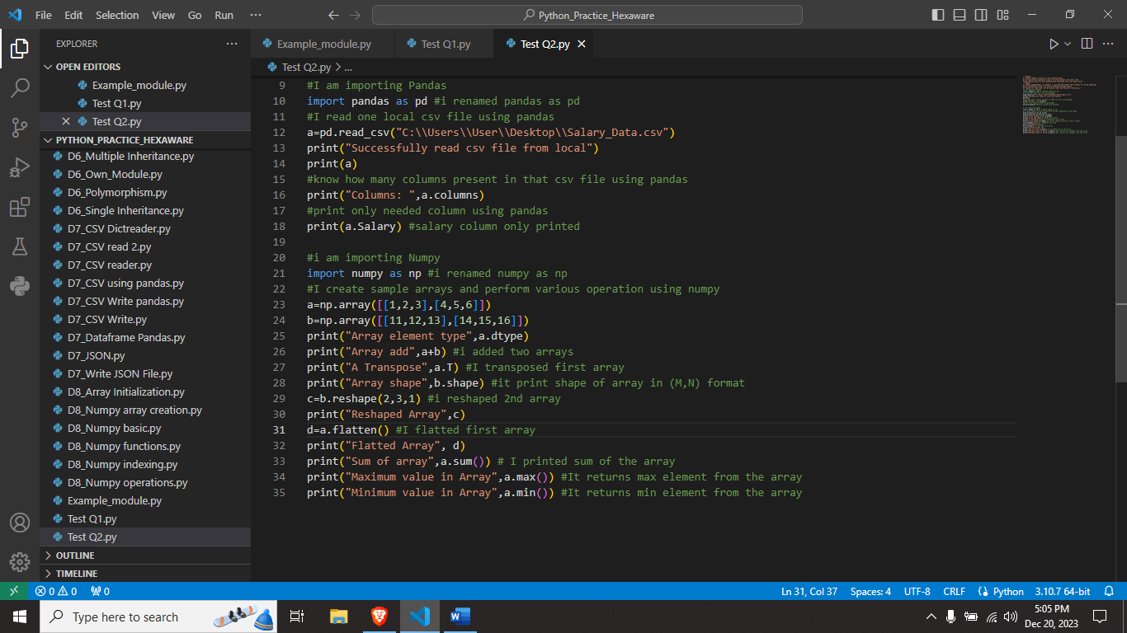

**Output:**

